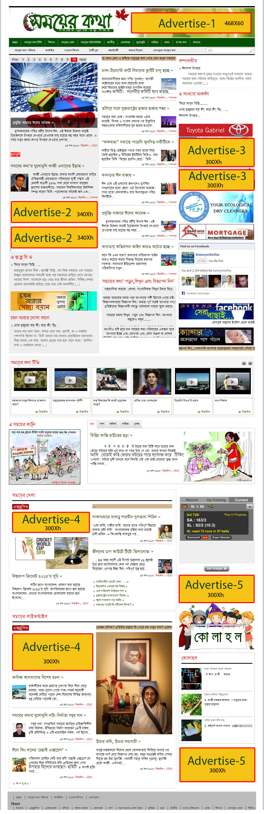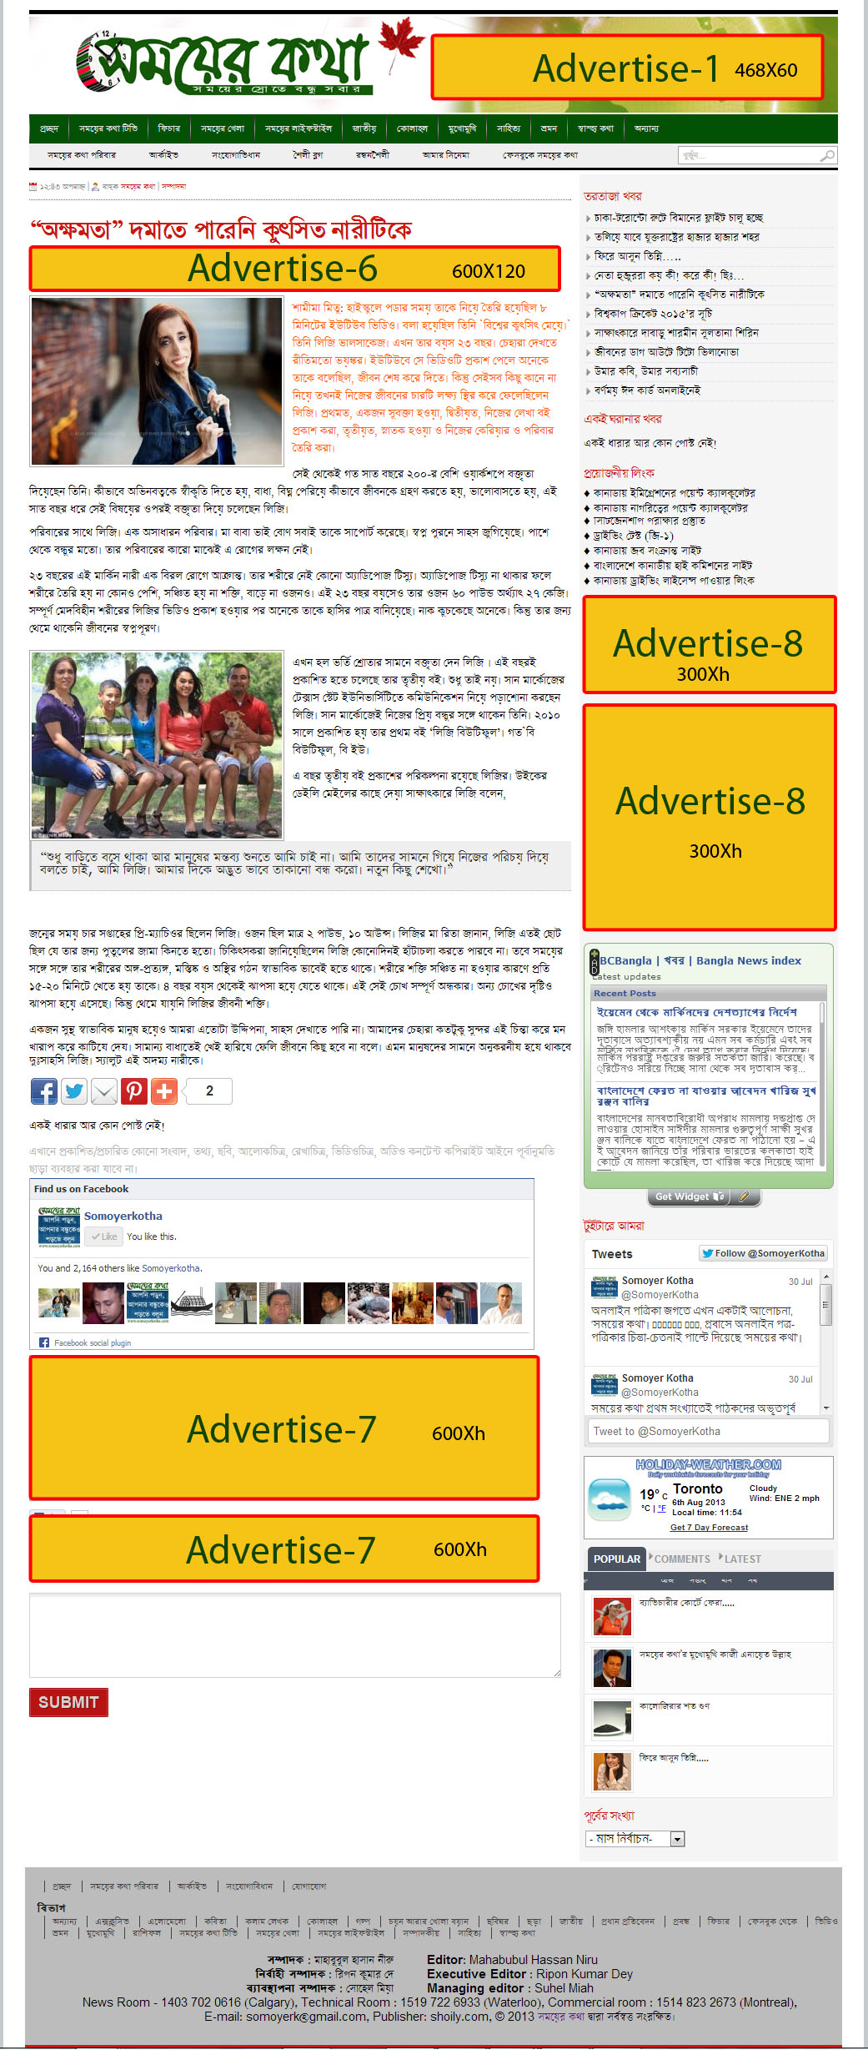

ADVERTISEMENT PACKAGES

 | Dimension  In pixel | Location | Acceptable formats | File size | Animation | Clickable | Rate (per month)'
Advertise 1 | 468 × 60 | Home, Article | JPEG, GIF, BMP, PNG, SWF | >45 kB | Yes | Yes$ | $200
Advertise 2 | 340 × h* | Home | JPEG, GIF, BMP, PNG, SWF | >40 kB | Yes | Yes$ | $140
Advertise 3 | 300 × h** | Home | JPEG, GIF, BMP, PNG, SWF | >40 kB | Yes | Yes$ | $120
Advertise 4 | 300 × h** | Home | JPEG, GIF, BMP, PNG, SWF | >40 kB | Yes | Yes$ | $110
Advertise 5 | 300 × h* | Home | JPEG, GIF, BMP, PNG, SWF | >40 kB | Yes | Yes$ | $100
Advertise 6 | 600 × 200 | Article | JPEG, GIF, BMP, PNG, SWF | >50 kB | No | Yes$ | $140
Advertise 7 | 600 × h* | Article | JPEG, GIF, BMP, PNG, SWF | >50 kB | Yes | Yes$ | $120
Advertise 8 | 300 × h* | Article | JPEG, GIF, BMP, PNG, SWF | >40 kB | Yes | Yes$ | $80
h* = (50 pixel - 450 pixel), h** = (50 pixel - 120 pixel)

'Note: For 3 months, the rate will be decreased to 5% and for 6 months, the rate will be decreased to 15%. Any other customizable sizes advertisement rate is negotiable.

I hereby agree to pay “Somoyer Kotha” 50% of the sums today and the rest will be paid two weeks before the agreements finish. I acknowledge that the above information is correct and accurate to the best of my knowledge and that I have properly read and understood the proposal.
Client Signature: ______________________ Date: _________________

Somoyer Kotha representative: ______________________________________________

